addpath 'Exp Data'

clc

clear all;

EE514 Advanced Topics in Automatic Control

Term Project Report Draft, Part 1

Dominic Riccoboni

Table of Contents

EE514 Advanced Topics in Automatic Control   
Term Project Report Draft, Part 1   
 Modelling   
 Determining System Parameters from Experimental Data   
 Motor Speed Constant and the Breakaway Voltage   
 Tachometer Constant   
 Inverting Power Amplifier Constant   
 Potentiometer Constant   
 Motor Time Constant   
 Static Torque Voltage Constant   
 Torque Required to Break Through the Static Friction in the Step Responses   
 Algebraically Determining the Remaining System Parameters   
 Relating Found System Parameters to a Nonlinear Motorized Pendulum Model   
 Summary of Numerical Constants   
 Nonlinear State Space Representation of the Motorized Pendulum   
 Stability Analysis   
 Natural Equilibrium Points   
 Stability of a Linear Quadratic Regulator about Upward Position   
 Simulated Step Responses of the System with Stiction and no Pendulum   
 Linear Quadratic Regulator Design   
 LQR Simulation 1 - Linear System Model   
 LQR Simulation 2 - Linear System Model   
 Simulation of the LQR Controller in the Nonlinear System   
 LQR Simulation Nonlinear System - First Attempt   
 LQR Simulation Nonlinear System - Iterated LQR Gains   
 LQR Simulation Nonlinear System - Final LQR Gains   
 Discussion

# 

# 

# Modelling

## Determining System Parameters from Experimental Data

First, the experimental data is imported and the values of system constants  and  are determined using various techniques. The data is found in the "SS_speeds_voltages_data.xlsx" excel spreadsheet located in the "Exp Data" repository sub-folder. The constants are defined:

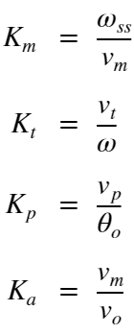

 is the motor speed constant (which is related to additional motor parameters below), the tachometer constant is , the potentiometer constant is, and the inverting power amplifier constant is . The variable  is the motor's steady state angular velocity reached when a step input voltage of  is applied. The voltage  is an output of the tachometer for any given instantanous motor angular velocity . For the position constant, the voltage  represents the potentiometer voltage reading given gear reduced ouput angle . This output angle is related to the motor shaft angle through gear ratio :

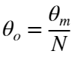.

In addition to these parameters, the motor-with-gearbox open loop time constant  must be determined from step response data provided. This, along with  (also determined experimentally) will provide for almost all of the relationships that will be needed to model the motor within the system. Their equations are:

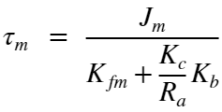

and

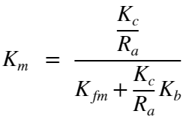

Where  is the motor's viscous damping coefficient,  is its armature resistance,  is its torque/current constant,  is its back emf constant, and  is the combined mass moment of inertia of the motor armature and the gearbox. One more experimental measurement is required - the ratio  can be ascertained from the static torque required to move the pendulum from equilibrium when it is at -90 degrees (horizontal). This static torque-voltage constant is found from:

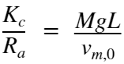

where is the mass of the pendulum bob,  is the gravitational constant, and  is the moment arm from the pendulum's point of rotation to the pendulum bob.

%%Set up the Import Options and Import the Steady State Speed vs. Voltage Data

%This portion of code was generated automatically in MATLAB using the "Import Data" tool

%and its "Generate Script" functionality. The file path for the readtable function call

% has been modified to work with the file system scheme used in this report. Additionally,

% the data originally output as an array is transfered into the struct "SS_w_v_dat".

opts = spreadsheetImportOptions("NumVariables", 4);

% Specify sheet and range

opts.Sheet = "Sheet1";

opts.DataRange = "A3:D13";

% Specify column names and types

opts.VariableNames = ["MotorSpeed", "Vo", "Vm", "VT"];

opts.VariableTypes = ["double", "double", "double", "double"];

% Import the data

SSspeedsvoltagesdata = readtable("\Exp Data\SS_speeds_voltages_data.xlsx", opts, "UseExcel", false);

%%Convert to output type to an array and then fill a struct with the data

SSspeedsvoltagesdata = table2array(SSspeedsvoltagesdata);

SS_w_v_dat.MotorSpeed = SSspeedsvoltagesdata(:,1);

SS_w_v_dat.Vo = SSspeedsvoltagesdata(:,2);

SS_w_v_dat.Vm = SSspeedsvoltagesdata(:,3);

SS_w_v_dat.Vt = SSspeedsvoltagesdata(:,4);

%%Clear temporary variables

clear opts SSspeedsvoltagesdata

%%Sort the Data By Increasing Values of Motor Speed

[MotorSpeed, I] = sort(SS_w_v_dat.MotorSpeed);

SS_w_v_dat.MotorSpeed = MotorSpeed;

SS_w_v_dat.Vm = SS_w_v_dat.Vm(I);

SS_w_v_dat.Vt = SS_w_v_dat.Vt(I);

SS_w_v_dat.Vo = SS_w_v_dat.Vo(I);

clear MotorSpeed

%%Set up the Import Options and Import the Position Sensor Data

%This portion of code was generated automatically in MATLAB using the "Import Data" tool

%and its "Generate Script" functionality. The file path for the readtable function call

% has been modified to work with the file system scheme used in this report.

opts = delimitedTextImportOptions("NumVariables", 3);

% Specify range and delimiter

opts.DataLines = [12, Inf];

opts.Delimiter = ",";

% Specify column names and types

opts.VariableNames = ["Times", "Channel2V", "Math1V"];

opts.VariableTypes = ["double", "double", "double"];

% Specify file level properties

opts.ExtraColumnsRule = "ignore";

opts.EmptyLineRule = "read";

% Import the data

PositionSensor = readtable("\Exp Data\PositionSensor.csv", opts);

%% Convert to output type

PositionSensor = table2array(PositionSensor);

%% Clear temporary variables

clear opts

%%Set up the Import Options and Import the Step Response 1 Data

%This portion of code was generated automatically in MATLAB using the "Import Data" tool

%and its "Generate Script" functionality. The file path for the readtable function call

% has been modified to work with the file system scheme used in this report.

opts = delimitedTextImportOptions("NumVariables", 3);

% Specify range and delimiter

opts.DataLines = [12, Inf];

opts.Delimiter = ",";

% Specify column names and types

opts.VariableNames = ["Times", "Channel2V", "Math1V"];

opts.VariableTypes = ["double", "double", "double"];

% Specify file level properties

opts.ExtraColumnsRule = "ignore";

opts.EmptyLineRule = "read";

% Import the data

Step1 = readtable("\Exp Data\Step1.csv", opts);

%% Convert to output type

Step1 = table2array(Step1);

%% Clear temporary variables

clear opts

%%Set up the Import Options and Import the Step Response 2 Data

opts = delimitedTextImportOptions("NumVariables", 3);

% Specify range and delimiter

opts.DataLines = [12, Inf];

opts.Delimiter = ",";

% Specify column names and types

opts.VariableNames = ["Times", "Channel2V", "Math1V"];

opts.VariableTypes = ["double", "double", "double"];

% Specify file level properties

opts.ExtraColumnsRule = "ignore";

opts.EmptyLineRule = "read";

% Import the data

Step2 = readtable("\Exp Data\Step2.csv", opts);

%% Convert to output type

Step2 = table2array(Step2);

%% Clear temporary variables

clear opts

%%Set up the Import Options and Import the Step Response 3 Data

opts = delimitedTextImportOptions("NumVariables", 3);

% Specify range and delimiter

opts.DataLines = [12, Inf];

opts.Delimiter = ",";

% Specify column names and types

opts.VariableNames = ["Times", "Channel2V", "Math1V"];

opts.VariableTypes = ["double", "double", "double"];

% Specify file level properties

opts.ExtraColumnsRule = "ignore";

opts.EmptyLineRule = "read";

% Import the data

Step3 = readtable("\Exp Data\Step3.csv", opts);

%% Convert to output type

Step3 = table2array(Step3);

%% Clear temporary variables

clear opts

### 

### Motor Speed Constant and the Breakaway Voltage

BA_index = SS_w_v_dat.MotorSpeed == 0; %Datapoints before the breakaway voltage is reached

 is determined from the slope of a linear curve fit to the non-zero data points.

Km_fit = polyfit(SS_w_v_dat.Vm(~BA_index),SS_w_v_dat.MotorSpeed(~BA_index),1);

fprintf(['Km is found to be ' num2str(round(Km_fit(1),1)) ' [RPM/V]'])

Km is found to be 220.9 [RPM/V]

Breakaway voltage, , is determined by finding x intercept of the linear curve fit to all non-zero voltage data points.

v_ba = -Km_fit(2)/Km_fit(1);

fprintf(['Breakaway voltage is found to be ' num2str(v_ba) ' [V]'])

Breakaway voltage is found to be 1.0684 [V]

figure

plot(SS_w_v_dat.Vm(BA_index),SS_w_v_dat.MotorSpeed(BA_index), 'r x',...

SS_w_v_dat.Vm(~BA_index),SS_w_v_dat.MotorSpeed(~BA_index), 'b x',...

[v_ba 12],[0 Km_fit(1)*12 + Km_fit(2)],'g')

xlabel('v_m [V]')

ylabel('\omega_{ss} [RPM]')

title('Steady State Motor Speed vs Armature Voltage Plot')

%Breakaway Location Annotation

ax = gca;

LArr = .1; %Length of Arrow

PhiArr = deg2rad(30);

%Arrow Head

[xh, yh] = ds2nfu(ax,SS_w_v_dat.Vm(length(SS_w_v_dat.Vm(BA_index))), 0);

%Arrow Tail

xt = xh + LArr*cos(PhiArr);

yt = yh + LArr*sin(PhiArr);

annotation('textarrow',[xt xh],[yt yh],'String',['Breakaway Voltage = '...

num2str(round(v_ba,4)) '[V]'],'FontSize',10,'Linewidth',1)

%Slope Annotation

ax = gca;

LArr = .15; %Length of Arrow

PhiArr = deg2rad(110);

%Arrow Head

[xh, yh] = ds2nfu(ax,6, Km_fit(1)*6 + Km_fit(2));

%Arrow Tail

xt = xh + LArr*cos(PhiArr);

yt = yh + LArr*sin(PhiArr);

annotation('textarrow',[xt xh],[yt yh],'String',['K_m = '...

num2str(round(Km_fit(1),1)) '[RPM/V]'],'FontSize',10,'Linewidth',1)



### Tachometer Constant

A linear curve fit is used to approximate the tachometer measurement constant 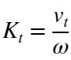 from experimental data.

Kt_fit = polyfit(SS_w_v_dat.MotorSpeed,SS_w_v_dat.Vt,1);

fprintf(['Kt is found to be ' num2str(round(Kt_fit(1),3)) ' [V/RPM]'])

Kt is found to be -0.015 [V/RPM]

figure

plot(SS_w_v_dat.MotorSpeed,SS_w_v_dat.Vt, 'b x',[0 2300],[0 Kt_fit(1)*2300 + Kt_fit(2)],'g' )

xlabel('Motor Speed [RPM]')

ylabel('Tachometer Voltage [V]')

title('Motor Speed vs Tachometer Voltage Reading')

%Slope Annotation

ax = gca;

LArr = .05; %Length of Arrow

PhiArr = deg2rad(45);

%Arrow Head

[xh, yh] = ds2nfu(ax,1250, Kt_fit(1)*1250 + Kt_fit(2));

%Arrow Tail

xt = xh + LArr*cos(PhiArr);

yt = yh + LArr*sin(PhiArr);

annotation('textarrow',[xt xh],[yt yh],'String',['K_t = ' ...

num2str(round(Kt_fit(1),3)) '[V/RPM]'],'FontSize',10,'Linewidth',1)



### Inverting Power Amplifier Constant

A linear curve fit is used to approximate the tachometer measurement constant 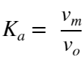 from experimental data.

Ka_fit = polyfit(SS_w_v_dat.Vo,SS_w_v_dat.Vm,1);

fprintf(['Ka is found to be ' num2str(Ka_fit(1)) ' [V/V]'])

Ka is found to be -5.0204 [V/V]

figure

plot(SS_w_v_dat.Vo,SS_w_v_dat.Vm, 'b x',[0 -2.1],[0 Ka_fit(1)*-2.1 + Ka_fit(2)],'g' )

xlabel('Inverting Op Amp Output Voltage v_o [V]')

ylabel('Motor Voltage, v_m [V]')

title('Armature Voltage vs Op Amp Voltage')

%Slope Annotation

ax = gca;

LArr = .05; %Length of Arrow

PhiArr = deg2rad(45);

%Arrow Head

[xh, yh] = ds2nfu(ax,-1.25, Ka_fit(1)*-1.25 + Ka_fit(2));

%Arrow Tail

xt = xh + LArr*cos(PhiArr);

yt = yh + LArr*sin(PhiArr);

annotation('textarrow',[xt xh],[yt yh],'String',['K_a = ' ...

num2str(round(Ka_fit(1),3)) '[V/V]'],'FontSize',10,'Linewidth',1)



### Potentiometer Constant

Data is separated (roughly) by linear regions of the sawtooth wave and a linear curve fit is given to each. The slopes are then averaged to determine a value in volts per second.

I_p_1 = ((.15 < PositionSensor(:,1)) & (PositionSensor(:,1) < .55));

I_p_2 = ((.63 < PositionSensor(:,1)) & (PositionSensor(:,1) < 1.1));

I_p_3 = ((1.25 < PositionSensor(:,1)) & (PositionSensor(:,1) < 1.75));

m_fit1 = polyfit(PositionSensor(I_p_1,1),PositionSensor(I_p_1,3),1);

fprintf(['First slope fit is ' num2str(m_fit1(1)) ' [V/s]'])

First slope fit is 52.207 [V/s]

m_fit2 = polyfit(PositionSensor(I_p_2,1),PositionSensor(I_p_2,3),1);

fprintf(['Second slope fit is ' num2str(m_fit2(1)) ' [V/s]'])

Second slope fit is 52.496 [V/s]

m_fit3 = polyfit(PositionSensor(I_p_3,1),PositionSensor(I_p_3,3),1);

fprintf(['Third slope fit is ' num2str(m_fit3(1)) ' [V/s]'])

Third slope fit is 52.6473 [V/s]

figure

plot(PositionSensor(:,1),PositionSensor(:,3),'-',...

[(-17 - m_fit1(2))/m_fit1(1) (17 - m_fit1(2))/m_fit1(1)],[-17 17],'g',...

[(-17 - m_fit2(2))/m_fit2(1) (17 - m_fit2(2))/m_fit2(1)],[-17 17],'g' ,...

[(-17 - m_fit3(2))/m_fit3(1) (17 - m_fit3(2))/m_fit3(1)],[-17 17],'g' )

xlabel('Time [s]')

ylabel('Potentiometer Voltage Reading [V]')

title('Potentiometer Voltage vs Time')

%Slope Annotations

ax = gca;

% m_fit1

LArr = .15; %Length of Arrow

PhiArr = deg2rad(112);

%Arrow Head

[xh, yh] = ds2nfu(ax,.5, m_fit1(1)*.5 + m_fit1(2));

%Arrow Tail

xt = xh + LArr*cos(PhiArr);

yt = yh + LArr*sin(PhiArr);

annotation('textarrow',[xt xh],[yt yh],'String',['m1 = ' ...

num2str(round(m_fit1(1),3)) '[V/s]'],'FontSize',10,'Linewidth',1)

% m_fit2

LArr = .1; %Length of Arrow

PhiArr = deg2rad(110);

%Arrow Head

[xh, yh] = ds2nfu(ax,1, m_fit2(1)*1 + m_fit2(2));

%Arrow Tail

xt = xh + LArr*cos(PhiArr);

yt = yh + LArr*sin(PhiArr);

annotation('textarrow',[xt xh],[yt yh],'String',['m2 = ' ...

num2str(round(m_fit2(1),3)) '[V/s]'],'FontSize',10,'Linewidth',1)

% m_fit3

LArr = .175; %Length of Arrow

PhiArr = deg2rad(-75);

%Arrow Head

[xh, yh] = ds2nfu(ax,1.35, m_fit3(1)*1.35 + m_fit3(2));

%Arrow Tail

xt = xh + LArr*cos(PhiArr);

yt = yh + LArr*sin(PhiArr);

annotation('textarrow',[xt xh],[yt yh],'String',['m3 = ' ...

num2str(round(m_fit3(1),3)) '[V/s]'],'FontSize',10,'Linewidth',1)



The period of the sawtooth waveform is found by manually finding the timespan associated with the initial and final positive peak of the data and dividing that by three.

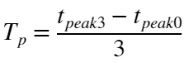

Using the average of the slopes determined from the three linear curve fits above,  is computed.

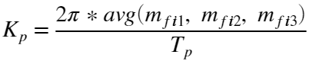

%Display time peak 3

figure

plot(PositionSensor(:,1),PositionSensor(:,3),'-',...

[(-17 - m_fit1(2))/m_fit1(1) (17 - m_fit1(2))/m_fit1(1)],[-17 17],'g',...

[(-17 - m_fit2(2))/m_fit2(1) (17 - m_fit2(2))/m_fit2(1)],[-17 17],'g' ,...

[(-17 - m_fit3(2))/m_fit3(1) (17 - m_fit3(2))/m_fit3(1)],[-17 17],'g' )

xlabel('Time [s]')

ylabel('Potentiometer Voltage Reading [V]')

title('Potentiometer Voltage vs Time')

ax3 = gca;

chart2 = ax3.Children(4);

datatip(chart2,1.763,15.41);



%Display time peak 0

figure

plot(PositionSensor(:,1),PositionSensor(:,3),'-',...

[(-17 - m_fit1(2))/m_fit1(1) (17 - m_fit1(2))/m_fit1(1)],[-17 17],'g',...

[(-17 - m_fit2(2))/m_fit2(1) (17 - m_fit2(2))/m_fit2(1)],[-17 17],'g' ,...

[(-17 - m_fit3(2))/m_fit3(1) (17 - m_fit3(2))/m_fit3(1)],[-17 17],'g' )

xlabel('Time [s]')

ylabel('Potentiometer Voltage Reading [V]')

title('Potentiometer Voltage vs Time')

ax2 = gca;

chart = ax2.Children(4);

datatip(chart,0.016,15.3);



%Compute the period

period_st_wave = (1.763 - 0.016)/3;

fprintf(['T_p is found to be ' num2str(round(period_st_wave,3)) ' [sec]'])

T_p is found to be 0.582 [sec]

%Compute the Kp value

Kp = -mean([m_fit1(1) m_fit2(1) m_fit3(1)])*period_st_wave/(2*pi);

fprintf(['K_p is found to be ' num2str(round(Kp,1)) ' [V/rad]'])

K_p is found to be -4.9 [V/rad]

The  value is slightly less than the expected value of 30 one gets from visually inspecting the data. This is because there is a deadzone nonlinearity present in the potentiometer that occurs right around the rollover point.

### 

### Motor Time Constant

First, an estimate of the steady state voltage is found by averaging a range of values near the end of the data collected for each step response. The final one percent of the data points are used for each calculation.

Index_i_1 = length(Step1(:,1)) - round(length(Step1(:,1))/100);

v_ss_1 = mean(Step1(Index_i_1:end,3));

fprintf(['Steady state tachometer reading 1 is found to be ' num2str(round(v_ss_1,3)) ...

' [Volts]'])

Steady state tachometer reading 1 is found to be 23.364 [Volts]

Index_i_2 = length(Step2(:,1)) - round(length(Step2(:,1))/100);

v_ss_2 = mean(Step2(Index_i_2:end,3));

fprintf(['Steady state tachometer reading 2 is found to be ' num2str(round(v_ss_2,3)) ...

' [Volts]'])

Steady state tachometer reading 2 is found to be 25.031 [Volts]

Index_i_3 = length(Step3(:,1)) - round(length(Step3(:,1))/100);

v_ss_3 = mean(Step3(Index_i_3:end,3));

fprintf(['Steady state tachometer reading 3 is found to be ' num2str(round(v_ss_3,3))...

' [Volts]'])

Steady state tachometer reading 3 is found to be 14.092 [Volts]

To better estimate the time constant, a 100 point moving mean is used to attempt to smooth out the data in the transient regions. This is shown in red and overlays the raw data plotted below.

k = 100;

%Step response 1 smoothed

Step1_movmean = movmean(Step1(:,3),k);

t_Step1_movmean = linspace(Step1(1,1), Step1(end,1), length(Step1(:,1))).';

%Step response 2 smoothed

Step2_movmean = movmean(Step2(:,3),k);

t_Step2_movmean = linspace(Step2(1,1), Step2(end,1), length(Step2(:,1))).';

%Step response 3 smoothed

Step3_movmean = movmean(Step3(:,3),k);

t_Step3_movmean = linspace(Step3(1,1), Step3(end,1), length(Step3(:,1))).';

Next, the first voltage to exceed 63.21% of the step response's steady state voltage is found from the *averaged* data, not the raw data. Its associated time is taken to be the time constant for the response.

mask_tau1 = Step1_movmean <= v_ss_1*.6321;

[v_tau1, I_tau1] = max(Step1(mask_tau1,3));

tau1 = Step1(I_tau1,1);

fprintf(['Time constant for step response 1 is found to be ' num2str(tau1) ' [s]'])

Time constant for step response 1 is found to be 0.28634 [s]

mask_tau2 = Step2_movmean <= v_ss_2*.6321;

[v_tau2, I_tau2] = max(Step2(mask_tau2,3));

tau2 = Step2(I_tau2,1);

fprintf(['Time constant for step response 2 is found to be ' num2str(tau2) ' [s]'])

Time constant for step response 2 is found to be 0.27293 [s]

mask_tau3 = Step3_movmean <= v_ss_3*.6321;

[v_tau3, I_tau3] = max(Step3(mask_tau3,3));

tau3 = Step3(I_tau3,1);

fprintf(['Time constant for step response 3 is found to be ' num2str(tau3) ' [s]'])

Time constant for step response 3 is found to be 0.25984 [s]

Finally, the motor's time constant is taken to be the average of these three values

tau = mean([tau1 tau2 tau3]);

fprintf(['The motor time constant is found to be ' num2str(round(tau,3)) ' [s]'])

The motor time constant is found to be 0.273 [s]

Finally, results are plotted with raw data, smoothed data, steady state voltage value, and associated time constants overlayed.

**Plot of Step Response 1:**

figure

plot(Step1(:,1), Step1(:,3), '.',t_Step1_movmean,Step1_movmean, 'r', ...

[min(Step1(:,1)) max(Step1(:,1))],[v_ss_1 v_ss_1], 'g', 'LineWidth', 1.5)

xlabel('Time [s]')

ylabel('Tachometer Voltage [V]')

xlim([min(Step1(:,1)) max(Step1(:,1))])

%Annotations

ax = gca;

% Steady State Voltage

LArr = .1; %Length of Arrow

PhiArr = deg2rad(-30);

%Arrow Head

[xh, yh] = ds2nfu(ax,min(Step1(:,1)), v_ss_1);

%Arrow Tail

xt = xh + LArr*cos(PhiArr);

yt = yh + LArr*sin(PhiArr);

annotation('textarrow',[xt xh],[yt yh],'String',['V_{t,ss} = ' ...

num2str(round(v_ss_1,3)) '[V]'],'FontSize',10,'Linewidth',1)

% Time constant

LArr = .1; %Length of Arrow

PhiArr = deg2rad(-30);

%Arrow Head

[xh, yh] = ds2nfu(ax, tau1,v_tau1);

%Arrow Tail

xt = xh + LArr*cos(PhiArr);

yt = yh + LArr*sin(PhiArr);

annotation('textarrow',[xt xh],[yt yh],'String',['\tau_1 = ' ...

num2str(round(tau1,3)) ' [s] at a value of ' num2str(round(v_tau1, 1)) ...

' [V]'],'FontSize',10,'Linewidth',1)



**Plot of Step Response 2:**

figure

plot(Step2(:,1), Step2(:,3), '.',t_Step2_movmean,Step2_movmean, ...

'r', [min(Step2(:,1)) max(Step2(:,1))],[v_ss_2 v_ss_2], 'g', 'LineWidth', 1.5)

xlabel('Time [s]')

ylabel('Tachometer Voltage [V]')

xlim([min(Step2(:,1)) max(Step2(:,1))])

%Annotations

ax = gca;

% Steady State Voltage

LArr = .1; %Length of Arrow

PhiArr = deg2rad(-30);

%Arrow Head

[xh, yh] = ds2nfu(ax,min(Step2(:,1)), v_ss_2);

%Arrow Tail

xt = xh + LArr*cos(PhiArr);

yt = yh + LArr*sin(PhiArr);

annotation('textarrow',[xt xh],[yt yh],'String',['V_{t,ss} = '...

num2str(round(v_ss_2,3)) '[V]'],'FontSize',10,'Linewidth',1)

% Time constant

LArr = .1; %Length of Arrow

PhiArr = deg2rad(-30);

%Arrow Head

[xh, yh] = ds2nfu(ax, tau2,v_tau2);

%Arrow Tail

xt = xh + LArr*cos(PhiArr);

yt = yh + LArr*sin(PhiArr);

annotation('textarrow',[xt xh],[yt yh],'String',['\tau_2 = ' ...

num2str(round(tau2,3)) ' [s] at a value of ' num2str(round(v_tau2, 1)) ...

' [V]'],'FontSize',10,'Linewidth',1)



**Plot of Step Response 3:**

figure

plot(Step3(:,1), Step3(:,3), '.',t_Step3_movmean,Step3_movmean, 'r', ...

[min(Step3(:,1)) max(Step3(:,1))],[v_ss_3 v_ss_3], 'g', 'LineWidth', 1.5)

xlabel('Time [s]')

ylabel('Tachometer Voltage [V]')

xlim([min(Step3(:,1)) max(Step3(:,1))])

%Annotations

ax = gca;

% Steady State Voltage

LArr = .1; %Length of Arrow

PhiArr = deg2rad(-30);

%Arrow Head

[xh, yh] = ds2nfu(ax,min(Step3(:,1)), v_ss_3);

%Arrow Tail

xt = xh + LArr*cos(PhiArr);

yt = yh + LArr*sin(PhiArr);

annotation('textarrow',[xt xh],[yt yh],'String',['V_{t,ss} = '...

num2str(round(v_ss_3,3)) '[V]'],'FontSize',10,'Linewidth',1)

% Time constant

LArr = .1; %Length of Arrow

PhiArr = deg2rad(-30);

%Arrow Head

[xh, yh] = ds2nfu(ax, tau3,v_tau3);

%Arrow Tail

xt = xh + LArr*cos(PhiArr);

yt = yh + LArr*sin(PhiArr);

annotation('textarrow',[xt xh],[yt yh],'String',['\tau_3 = '...

num2str(round(tau3,3)) ' [s] at a value of ' num2str(round(v_tau3, 1))...

' [V]'],'FontSize',10,'Linewidth',1)



### Static Torque Voltage Constant



Where





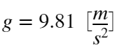



M_n = 28e-3; %[kg]

L_n = 11*.0254; %[m]

g_n = 9.81; %[m/s^2]

vm0 = 0.66; %[V]

KcRa = M_n*g_n*L_n/vm0;

fprintf(['The static torque voltage constant is found to be '...

num2str(round(KcRa,4)) ' [Nm/V]'])

The static torque voltage constant is found to be 0.1163 [Nm/V]

### 

### Torque Required to Break Through the Static Friction in the Step Responses

The motor circuit is modelled in the following manner.

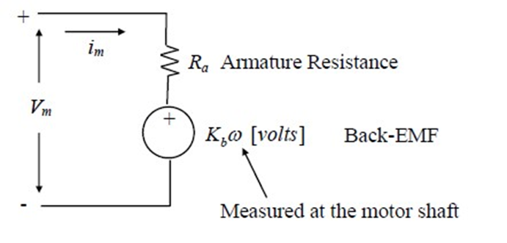

In the static friction case, when the motor is stalled, no  has developed in the system and all the electrical power is being dissipated as heat through . The armature KVL in this scenario is simply



The torque produced by a DC motor is given by



Therefore,

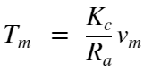

The torque required to break the system out stall, , is related to the breakaway voltage, , from the  vs  dataset through the stalled motor condition. At the tipping point

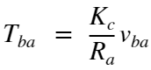

There is an inherent assumption here that most of the static friction torque is lumped at the motor side of the speed reducer, not the pendulum side. In reality, there is a contribution to stiction from the individual mechanical elements of the reducer. Since it would be out of the scope of this report to determine what exactly is contributing to stiction and its consequence on the static force balance problem, this is an assumption that must be made.

T_ba_n = KcRa*v_ba;

fprintf(['The breakaway torque is found to be ' num2str(round(T_ba_n,4)) ' [Nm]'])

The breakaway torque is found to be 0.1242 [Nm]

### 

### Algebraically Determining the Remaining System Parameters

First, convert constants to SI units

Km = Km_fit(1)*2*pi/60; %[(rad/s)/V]

fprintf(['The motor velocity constant Km is ' num2str(round(Km,3)) ' [rad/Vs]'])

The motor velocity constant Km is 23.133 [rad/Vs]

Kt = Kt_fit(1)*60/(2*pi); %[V/(rad/s)]

fprintf(['The tachometer constant Kt is ' num2str(round(Kt,3)) ' [Vs/rad]'])

The tachometer constant Kt is -0.143 [Vs/rad]

The friction constant  and back emf constant  are common to both  and  and can be eliminated. This allows us to solve for the motor inertia in terms of other known constants.

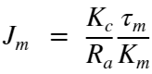

Jm = KcRa*tau/Km;

fprintf(['The motor polor moment of inertia Jm is ' num2str(round(Jm,4)) ' [kg-m-s^2]'])

The motor polor moment of inertia Jm is 0.0014 [kg-m-s^2]

## 

## Relating Found System Parameters to a Nonlinear Motorized Pendulum Model

A schematic representation of the motorized pendulum system is shown below.

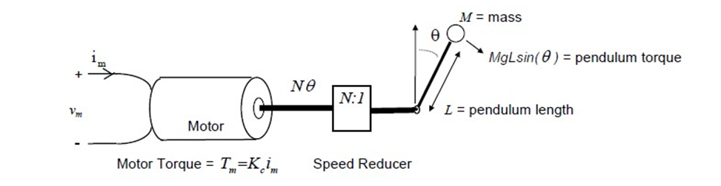

A nonlinear model of the pendulum kinetics is expressed in terms of an input armature voltage actuation as such:

syms K_c R_a v_m N J_m J_p theta_ddot K_fm K_b theta_dot M g L theta K_m T_ba

assume(K_c > 0 & R_a > 0 & J_m > 0 & J_p > 0 & K_fm > 0 & N > 0 & K_m > 0 )

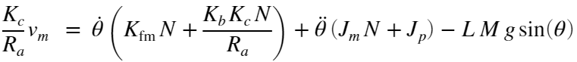

Where friction due to the pendulum itself is assumed to be negligible. The pendulum's moment of inertia, , is given by



Jp = L_n^2*M_n;

and  is a gear ratio between the motor shaft and the pendulum. The input to the system is voltage , the motor's armature voltage - this can be related to our control actuation  through . This will have to be done for all of the measured states as well so that gain selecting resistors can be placed in the physical electronics. From rearranging the equation for , the terms 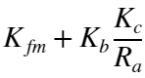 in the pendulum model can be eliminated in favor of known values.



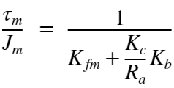

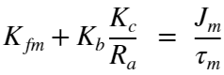

And from  above

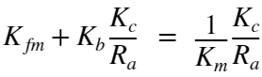

Hence

PendulumEOM = K_c/R_a*v_m == (N*J_m + J_p)*theta_ddot +...

N*1/K_m*K_c/R_a*theta_dot - M*g*L*sin(theta);

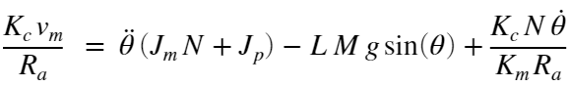

The above model excludes any modelling of additional nonlinearities in the system. The model will be supplemented with a coulomb friction with damping nonlinearity. This replaces the 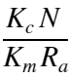 damping coefficient in the above model. This damping coefficient is captured by the nonlinear friction model in the slope of the linear regions of the  vs  plot below. Its offset is the breakaway torque required to overcome the stiction. The signum function inherent in this model will act as a switching law around zero pendulum/motor velocity that tends the system back to zero velocity if the net torques on the armature to not exceed a threshold.

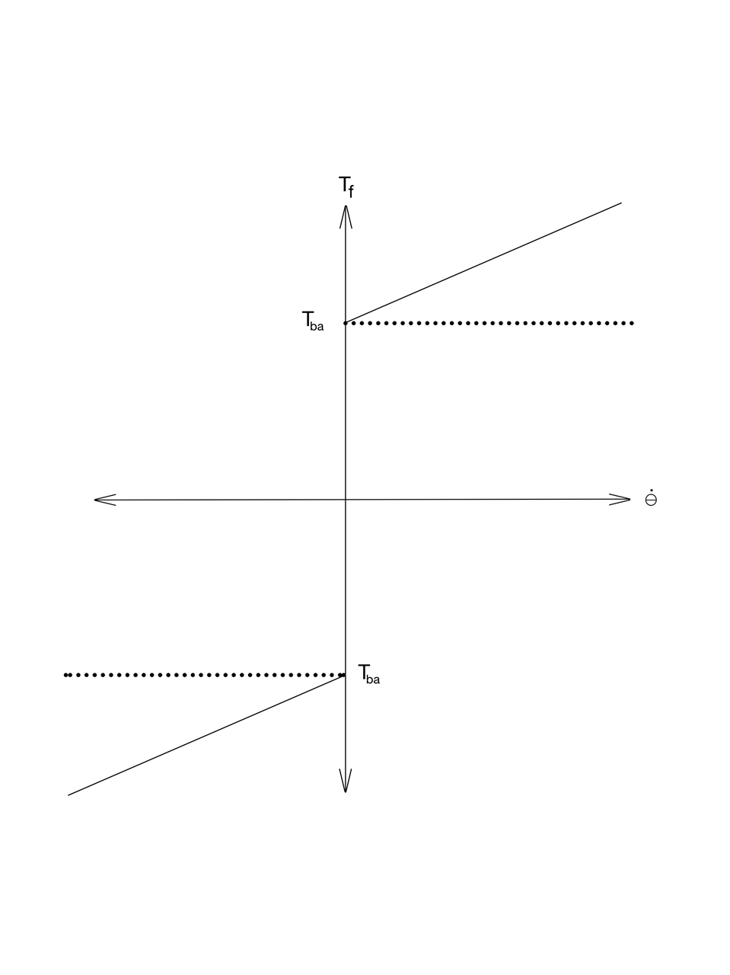

The analytical expression for the friction term  is

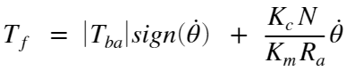

and the model pendulum EOM becomes

ModPendulumEOM = K_c/R_a*v_m == (N*J_m + J_p)*theta_ddot +...

N*1/K_m*K_c/R_a*theta_dot - T_ba*sign(theta_dot) - M*g*L*sin(theta);

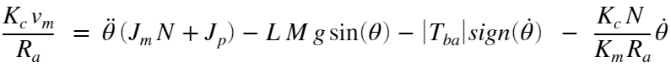

## Summary of Numerical Constants

This table summarizes the minimum number of constants, determined from experimental data, needed to implement the full nonlinear pendulum model in Simulink.

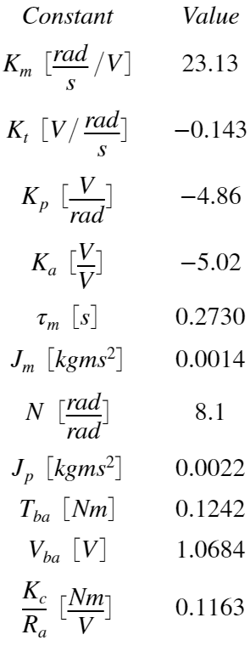

## 

## Nonlinear State Space Representation of the Motorized Pendulum

The nonlinear state space representation *excluding the stiction nonlinearity* is

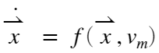

where . Hence,

NL_PendulumSS = [theta_dot;theta_ddot] == expand([theta_dot;...

rhs(isolate(PendulumEOM, theta_ddot))]);

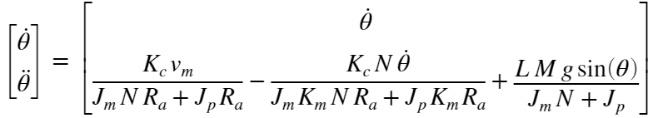

Taking the Jacobian with respect to the state yields

Jacobian(theta) = jacobian(rhs(NL_PendulumSS), [theta theta_dot]);

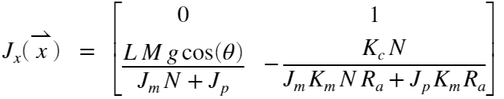

and the Jacobian with respect to the input is simply a linear input matrix B

B = equationsToMatrix(rhs(NL_PendulumSS), v_m);

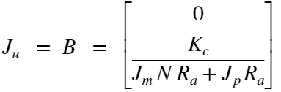

# Stability Analysis

It is clear from the  that the open loop () equilibrium points are located at , and . So, for  at integer multiples of , the pendulum is naturally stable when it is still. It is also possible to consider the actuated equilibrium points, ones where  is compensating for gravity at an arbitrary pendulum angle. One can imagine designing a feed-forward control law around those points where feed forward voltage  creates an equilibrium point at . A regulator around error states in position and velocity can then be analyzed for stability. There are likely many ways to consider stability in the actuated case, all depending on the control law utilized. This paper will focus on stability analysis of the natural equilibrium points as well as a closed loop stability analysis of the operating point at .

The two natural equilibrium points will be analyzed for open loop stability. The upward position, , will be shown asymptotically unstable using Lyapunov's indirect method. The downward position, , will be shown asymptotically stable using the same method. A stabilizing linear quadratic regulator will be designed about the upward operating point. Again, Lyapunov's indirect method will be used to argue for asymptotic stability of the closed loop system.

## Natural Equilibrium Points

Since  is an equilibrium point, it is valid to use Lyapunov's indirect method to make a statement about the asymptotic stability of the point. Eigenvalue analysis of the system's Jacobian evaluated at that point tells us if the point is asymptotically stable or unstable. The Jacobian here will be denoted 

N_n = 8.1;

NumJacobian(theta) = subs(Jacobian, [L, M, g, J_m, J_p, N, K_m]...

,[L_n, M_n, g_n, Jm, Jp, N_n, Km]);

NumJacobian(theta) = subs(NumJacobian, K_c/R_a, KcRa);

A1 = NumJacobian(0);

eig(A1);

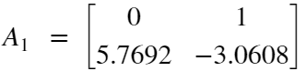

The eigenvalues of this matrix are

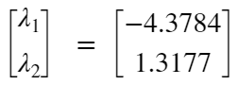

Since one of the eigenvalues is positive real, the point is asymptotically unstable.

The point  is also an equilibrium point. Its Jacobian is 

A2 = NumJacobian(pi);

eig(A2);

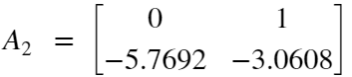

The eigenvalues of this matrix are

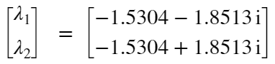

Since neither of these have a positive real part, the point is asymptotically stable.

## Stability of a Linear Quadratic Regulator about Upward Position

For an actuated system, the linearization necessary for Lyapunov's indirect method must include a nominal value of the actuation.



where



and



Since the system is naturally stable at the operating point, if  where , then

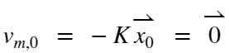

and



Therefore, a full state feedback law in absolute actuation is possible. A change of variables to deviation states will not be necessary to implement the linear controller. The linearized system with full state feedback has the closed loop matrix . If a  matrix is chosen such that the eigenvalues of  have negative real part, then the equilibrium point will be closed loop asymptotically stable. Since solutions to the linear quadratic regulator problem are guaranteed to produce stable eigenvalues in the closed loop matrix, our system will be asymptotically stable at the upward operating point. This will prove to be insufficient for good control, however. It only guarantees that there is *some* region in the state space for which trajectories that begin within that region will asymptotically approach the operating point. If it is desired to obtain information about the size of this region, additional Lyapunov techniques would be necessary. These alternatives will not be explored in this paper. Below is the linearized system for the LQR controller.

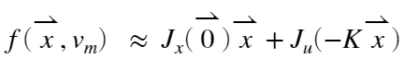

i.e.

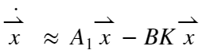

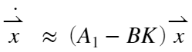

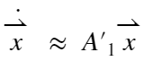

This stability analysis has not considered the nonlinear stiction present in the system. This could prove to be a problem for some controllers as high stiction could cause integrator windup, steady state error affecting the asymptotic nature of the equilibrium points, or some other type of effect. This analysis will only consider the stiction through simulation.

# 

# Simulated Step Responses of the System with Stiction and no Pendulum

This shows that the modelled system, with stiction, reproduces the steady state velocity vs armature voltage relationship - that the  and  values computed from raw data are represented in the model. Below is a plot of the raw data, original curve fit, and a set of steady state values from simulation step responses. The  value was utilized in the model along with the other constants determined above and the stiction nonlinearity. The  curve fit and the simulated data line up so perfectly that one set is hidden by the other. This is an indicator that, at the very least, the parameters found from experimental data are consistent with each other and with the model. It also indicates that significant elements of the raw data are represented by the simulation utilized in the control system design.

u_sel = 1;

tsim = 4;

r = 15;

omega_ss = zeros(r,1);

Steps = linspace(v_ba,12,r);

x0 = [0 0];

for i = 1:r

V_step = Steps(i);

StepOut = sim('Motor_Step_Response');

omega_ss(i) = StepOut.x(end,2)*60/(2*pi);

end

figure

plot([v_ba 12],[0 Km_fit(1)*12 + Km_fit(2)],'g',Steps,omega_ss, 'y',...

SS_w_v_dat.Vm(BA_index),SS_w_v_dat.MotorSpeed(BA_index), 'r x',...

SS_w_v_dat.Vm(~BA_index),SS_w_v_dat.MotorSpeed(~BA_index), 'b x' )

xlabel('v_m [V]')

ylabel('\omega_{ss} [RPM]')

title('Steady State Motor Speed vs Armature Voltage Plot')

legend('K_m curve fit', 'K_m simulation', 'Pre-breakaway raw data', ...

'Post-breakaway raw data','Location', 'northwest')



To illustrate that the transient response characteristics are captured by the model, the three experimental step responses are simulated and compared to the raw data.

%Simulate step response 1 and plot it alongside its empirical counterpart

V_step = (-v_ss_1/Kt_fit(1) - Km_fit(2))/Km_fit(1);

Step1_sim = sim('Motor_Step_Response');

omega_step1 = -Kt*Step1_sim.x(:,2);

figure

plot(Step1(:,1), Step1(:,3), '.',Step1_sim.tout,omega_step1, 'y',...

[min(Step1(:,1)) max(Step1(:,1))],[v_ss_1 v_ss_1], 'g', 'LineWidth', 1.5)

xlabel('Time [s]')

ylabel('Tachometer Voltage [V]')

title('Step 1 Comparison')

xlim([min(Step1(:,1)) max(Step1(:,1))])

legend('Raw data', 'Simulation', 'Steady State Tachometer Voltage','Location', 'southeast')



%Simulate step response 2 and plot it alongside its empirical counterpart

V_step = (-v_ss_2/Kt_fit(1) - Km_fit(2))/Km_fit(1);

Step2_sim = sim('Motor_Step_Response');

omega_step2 = -Kt*Step2_sim.x(:,2);

figure

plot(Step2(:,1), Step2(:,3), '.',Step2_sim .tout,omega_step2, 'y', ...

[min(Step2(:,1)) max(Step2(:,1))],[v_ss_2 v_ss_2], 'g', 'LineWidth', 1.5)

xlabel('Time [s]')

ylabel('Tachometer Voltage [V]')

title('Step 2 Comparison')

xlim([min(Step2(:,1)) max(Step2(:,1))])

legend('Raw data', 'Simulation','Steady State Tachometer Voltage', 'Location', 'southeast')



%Simulate step response 3 and plot it alongside its empirical counterpart

V_step = (-v_ss_3/Kt_fit(1) - Km_fit(2))/Km_fit(1);

Step3_sim = sim('Motor_Step_Response');

omega_step3 = -Kt*Step3_sim.x(:,2);

figure

plot(Step3(:,1), Step3(:,3), '.',Step3_sim .tout,omega_step3, 'y', ...

[min(Step3(:,1)) max(Step3(:,1))],[v_ss_3 v_ss_3], 'g', 'LineWidth', 1.5)

xlabel('Time [s]')

ylabel('Tachometer Voltage [V]')

title('Step 3 Comparison')

xlim([min(Step3(:,1)) max(Step3(:,1))])

legend('Raw data', 'Simulation','Steady State Tachometer Voltage', 'Location', 'southeast')



All three step responses match up very well with the experimental data. They all lie within the spread of the data, and they all approach the approximation of the steady state tachometer voltage. It is concluded that the motor modelling is, at least partially, successful. Meaningful conclusions can be drawn from the simulations below, so long as the influence of the pendulum is modelled well enough.

# Linear Quadratic Regulator Design

The Q and R matrices are initially chosen to give the  state about a quarter of the weighting of the  state. The controller shouldn't care so much if the pendulum moves quickly - what's more important is that the controller regulates it to the upward position. The R matrix is given a heavy weighting so as not to saturate the actuator. A controller that tries as hard as it can initially and then as hard as it can when the position overshoots might not actually be bad - but the design criteria will be for this not to occur. The initial input should land close to the 15V rails of the inverting power amplifier to allow for timeliness/aggressiveness of the response, but it will be capped at 10V for our purposes.

### LQR Simulation 1 - Linear System Model

Initially, weighting matrices are chosen as follows

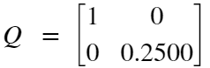



Q_theta = 1; %weighting on theta state

Q_thetad = 0.25*Q_theta; %weighting on theta dot state - we dont ...

% care as much about how fast the pendulum moves. We prefer lower positional oscillation

Q = [Q_theta 0;0 Q_thetad];

R = 5; %weighting on the voltage actuation

%Create numerical A1 matrix

A1_n = double(A1);

% Create a numerical B matrix

B = subs(B, [L, M, g, J_m, J_p, N, K_m],[L_n, M_n, g_n, Jm, Jp, N_n, Km]);

B = subs(B, K_c/R_a, KcRa);

B_n = double(B);

%C matrix is the identity

C = eye(2);

%No input to output coupling

D = 0;

%Get K matrix from LQR command

K = lqr(A1_n, B_n, Q,R);

Resulting in a gain matrix



Results of the LQR regulation control scheme produce a slow response and a much softer actuation than allowed by the proposed design criteria.

%Create closed loop state space object

SS_model = ss(A1_n - B_n*K,[0;0], C, D);

%Set initial conditions to zero velocity and theta of 110 degrees

x0 = [deg2rad(110), 0]';

%Run the simulation

[x_lin1, t_lin1] = initial(SS_model, x0);

vm_lin1 = zeros(size(t_lin1));

for i = 1:length(t_lin1)

vm_lin1(i) = -K*x_lin1(i,:)';

end

%Plot the results

figure

subplot(3,1,1)

plot(t_lin1,rad2deg(x_lin1(:,1)))

xlabel('time [s]')

ylabel('\theta [deg]')

title('Response Initial LQR Weights - Linear Model')

subplot(3,1,2)

plot(t_lin1,rad2deg(x_lin1(:,2)), 'g')

xlabel('time [s]')

yl_1 = ylabel('$\bf\dot{\theta}~ [deg/s]$');

set(yl_1, 'Interpreter', 'latex');

subplot(3,1,3)

plot(t_lin1,vm_lin1, 'r')

xlabel('time [s]')

ylabel('v_m [V]')

set(gcf,'position',[0,0,800,900]);



The response settles out at about 4 seconds and the maximum actuation is only, roughly -2.75 V. This control law did not come close enough to the desired 10V.

### LQR Simulation 2 - Linear System Model

The position error weighting is made even larger in anticipation of stiction effects in the nonlinear system. The actuation weighting is greatly decreased until the initial actuation is about 10V.

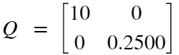



Q_theta = 10; %weighting on theta state

Q_thetad = 0.25*Q_theta; %weighting on theta dot state

Q = [Q_theta 0;0 Q_thetad];

R = .45; %weighting on the voltage actuation

%Get K matrix from LQR command

K = lqr(A1_n, B_n, Q,R);

Resulting in a gain matrix



%Create closed loop state space object

SS_model = ss(A1_n - B_n*K,[0;0], C, D);

%Set initial conditions to zero velocity and theta of 110 degrees

x0 = [deg2rad(110), 0]';

%Run the simulation

[x_lin1, t_lin1] = initial(SS_model, x0);

vm_lin1 = zeros(size(t_lin1));

for i = 1:length(t_lin1)

vm_lin1(i) = -K*x_lin1(i,:)';

end

%Plot the results

figure

subplot(3,1,1)

plot(t_lin1,rad2deg(x_lin1(:,1)))

xlabel('time [s]')

ylabel('\theta [deg]')

title('Response 2 Iterated LQR Weights - Linear Model')

subplot(3,1,2)

plot(t_lin1,rad2deg(x_lin1(:,2)), 'g')

xlabel('time [s]')

yl_1 = ylabel('$\bf\dot{\theta}~ [deg/s]$');

set(yl_1, 'Interpreter', 'latex');

subplot(3,1,3)

plot(t_lin1,vm_lin1, 'r')

xlabel('time [s]')

ylabel('v_m [V]')

set(gcf,'position',[0,0,800,900]);



This response achieves the 10V design goal and is tested on the nonlinear system below.

# 

# Simulation of the LQR Controller in the Nonlinear System

The Nonlinear Simulink implementation considers the measurement gains, the inverting op amp, and the inverting power amplifier.

Where the "Motorized Pendulum with Stiction" subsystem contains the equations of motion in pendulum  states

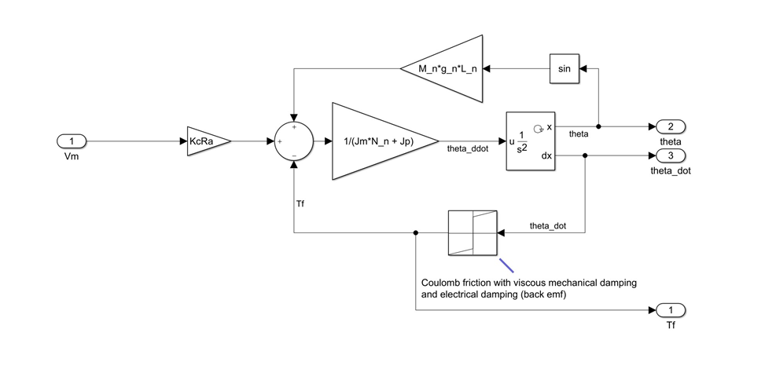

and the "Inverting Op Amp and Inverting Power Amplifier" subsystem contains the op amp gains associated with the physical hardware. The LQR gains must take these into account as well as the measurement gains.

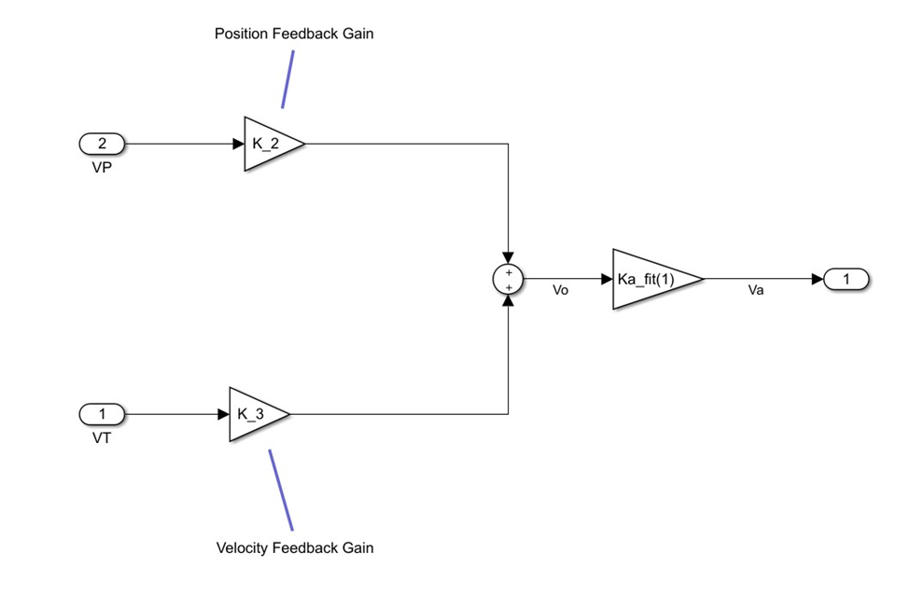

The LQR gains are altered in their sign to account for the inverting nature of the op amp, they are divided by their respective measurement gain, and they are divided by the inverting power amplifier gain. This is all to make the output of the physical hardware the correct scale.

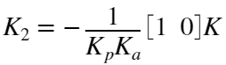

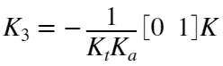

## LQR Simulation Nonlinear System - First Attempt

The nonlinear system with stiction is simulated using the Q and R matrices of the second LQR simulation for the linear system. Results are as follows

tsim = 1.5;

K_2 = -K(1)/(Kp*Ka_fit(1));

K_3 = -K(2)/(Kt*Ka_fit(1));

NLout = sim('Motorized_Pendulum');

%Plot the results

figure

subplot(3,1,1)

plot(NLout.tout,rad2deg(NLout.x(:,1)), [0 NLout.tout(end)], [0 0], '--' )

xlabel('time [s]')

ylabel('\theta [deg]')

title('Nonlinear Response 1 - original LQR Gains')

subplot(3,1,2)

plot(NLout.tout,rad2deg(NLout.x(:,2)), 'g')

xlabel('time [s]')

yl_1 = ylabel('$\bf\dot{\theta}~ [deg/s]$');

set(yl_1, 'Interpreter', 'latex');

subplot(3,1,3)

plot(NLout.tout,NLout.vm, 'r')

xlabel('time [s]')

ylabel('v_m [V]')

set(gcf,'position',[0,0,800,900]);

The nonlinear response overshoots the equilibrium point and then gets stuck in stiction at about . Further iteration will attempt to mitigate this steady state error - this will be done in the nonlinear system model.

Q_theta = 30; %weighting on theta state

Q_thetad = 0.25*Q_theta; %weighting on theta dot state

Q = [Q_theta 0;0 Q_thetad];

R = 2; %weighting on the voltage actuation

%Get K matrix from LQR command

K = lqr(A1_n, B_n, Q,R);

tsim = 1.5;

K_2 = -K(1)/(Kp*Ka_fit(1));

K_3 = -K(2)/(Kt*Ka_fit(1));

NLout = sim('Motorized_Pendulum');

### LQR Simulation Nonlinear System - Iterated LQR Gains

LQR gains are chosen as follows

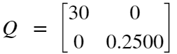



%Plot the results

figure

subplot(3,1,1)

plot(NLout.tout,rad2deg(NLout.x(:,1)), [0 NLout.tout(end)], [0 0], '--' )

xlabel('time [s]')

ylabel('\theta [deg]')

title('Nonlinear Response 2, Iterated LQR Gains')

subplot(3,1,2)

plot(NLout.tout,rad2deg(NLout.x(:,2)), 'g')

xlabel('time [s]')

yl_1 = ylabel('$\bf\dot{\theta}~ [deg/s]$');

set(yl_1, 'Interpreter', 'latex');

subplot(3,1,3)

plot(NLout.tout,NLout.vm, 'r')

xlabel('time [s]')

ylabel('v_m [V]')

set(gcf,'position',[0,0,800,900]);

It was found that increasing the position weighting did not fix the steady state error. Rather good results were achieved by decreasing the aggressiveness of the controller until the momentum of the pendulum is close to zero when near the vertical operating point. Essentially, the controller that just so happens to land the pendulum in a stiction region that is close to the operating point is the one that has the best performance. The stiction keeps the pendulum there, and the position error is too small to overcome it - but the pendulum is close to .

Q_theta = 2; %weighting on theta state

Q_thetad = 0.25*Q_theta; %weighting on theta dot state

Q = [Q_theta 0;0 Q_thetad];

R = .25; %weighting on the voltage actuation

%Get K matrix from LQR command

K = lqr(A1_n, B_n, Q,R);

tsim = 1.5;

K_2 = -K(1)/(Kp*Ka_fit(1));

K_3 = -K(2)/(Kt*Ka_fit(1));

NLout = sim('Motorized_Pendulum');

### LQR Simulation Nonlinear System - Final LQR Gains

A suitable response is found at Q and R matrices

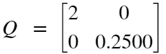



%Plot the results

figure

subplot(3,1,1)

plot(NLout.tout,rad2deg(NLout.x(:,1)), [0 NLout.tout(end)], [0 0], '--' )

xlabel('time [s]')

ylabel('\theta [deg]')

title('Nonlinear Response 2, Iterated LQR Gains')

subplot(3,1,2)

plot(NLout.tout,rad2deg(NLout.x(:,2)), 'g')

xlabel('time [s]')

yl_1 = ylabel('$\bf\dot{\theta}~ [deg/s]$');

set(yl_1, 'Interpreter', 'latex');

subplot(3,1,3)

plot(NLout.tout,NLout.vm, 'r')

xlabel('time [s]')

ylabel('v_m [V]')

set(gcf,'position',[0,0,800,900]);

It is found that decreasing R until the pendulum's velocity nears zero when theta is near zero produced a good result. The steady state position error was found to be roughly  which is somewhat close to the upward operating point.

figure

plot(NLout.tout,rad2deg(NLout.x(:,1)), [0 NLout.tout(end)], [0 0], '--' )

xlabel('time [s]')

ylabel('\theta [deg]')

title('Nonlinear Response 2, Iterated LQR Gains')

xlim([.5 1.5])

ylim([-1.5 1.5])

ax = gca;

% stiction transition annotation

LArr = .175; %Length of Arrow

PhiArr = deg2rad(-60);

%Arrow Head

[xh, yh] = ds2nfu(ax,.665, .924);

%Arrow Tail

xt = xh + LArr*cos(PhiArr);

yt = yh + LArr*sin(PhiArr);

annotation('textarrow',[xt xh],[yt yh],'String',...

'The static friction takes over here','FontSize',10,'Linewidth',1)

# 

# Discussion

Suitable LQR matrices were found that produce only a small steady state error of around , given the system's initial conditions. Because the system is nonlinear, the fine tuning of this particular situation will not necessarily hold for a different set of initial conditions. The controller is essentially relying on happenstance for its performance. For the situation where the pendulum is at rest, leaning on the table at , the controller should work so long as there are no egregious modelling errors.

There is only one steady state location that the controller's inability to overcome the stiction is inconsequential - it's the operating point. Any non-zero error will have a stiction force associated with it and if the error is too small, the resultant actuation isn't enough to overcome it. A good first step at making the linear controller work better in the presence of stiction would be to add in some integral action. It would have to be a slow integrator so that it doesn’t jolt the system through the stiction and become unstable in that manner, bouncing around equilibrium points in the "sticky" system.

To better determine whether model inaccuracies at large  values are a problem for a particular  matrix, Lyapunov analysis must be done using methods that consider the size of the region of stability. Since this was not done, any talk of what could potentially cause a stable LQR control scheme to be unstable in its nonlinear implementation is speculative. The major takeaway is that the behavior modelled by the linear representation is drastically different than that of the nonlinear system. This makes iterating on LQR matrices difficult and unpredictable. A nonlinear control technique, or even linear technique that modifies the LQR method above, is well motivated.